Globalization and its Socio-Economic Consequences

2020

21 – 22 October 2020

PROGRAM
globalizacia.com

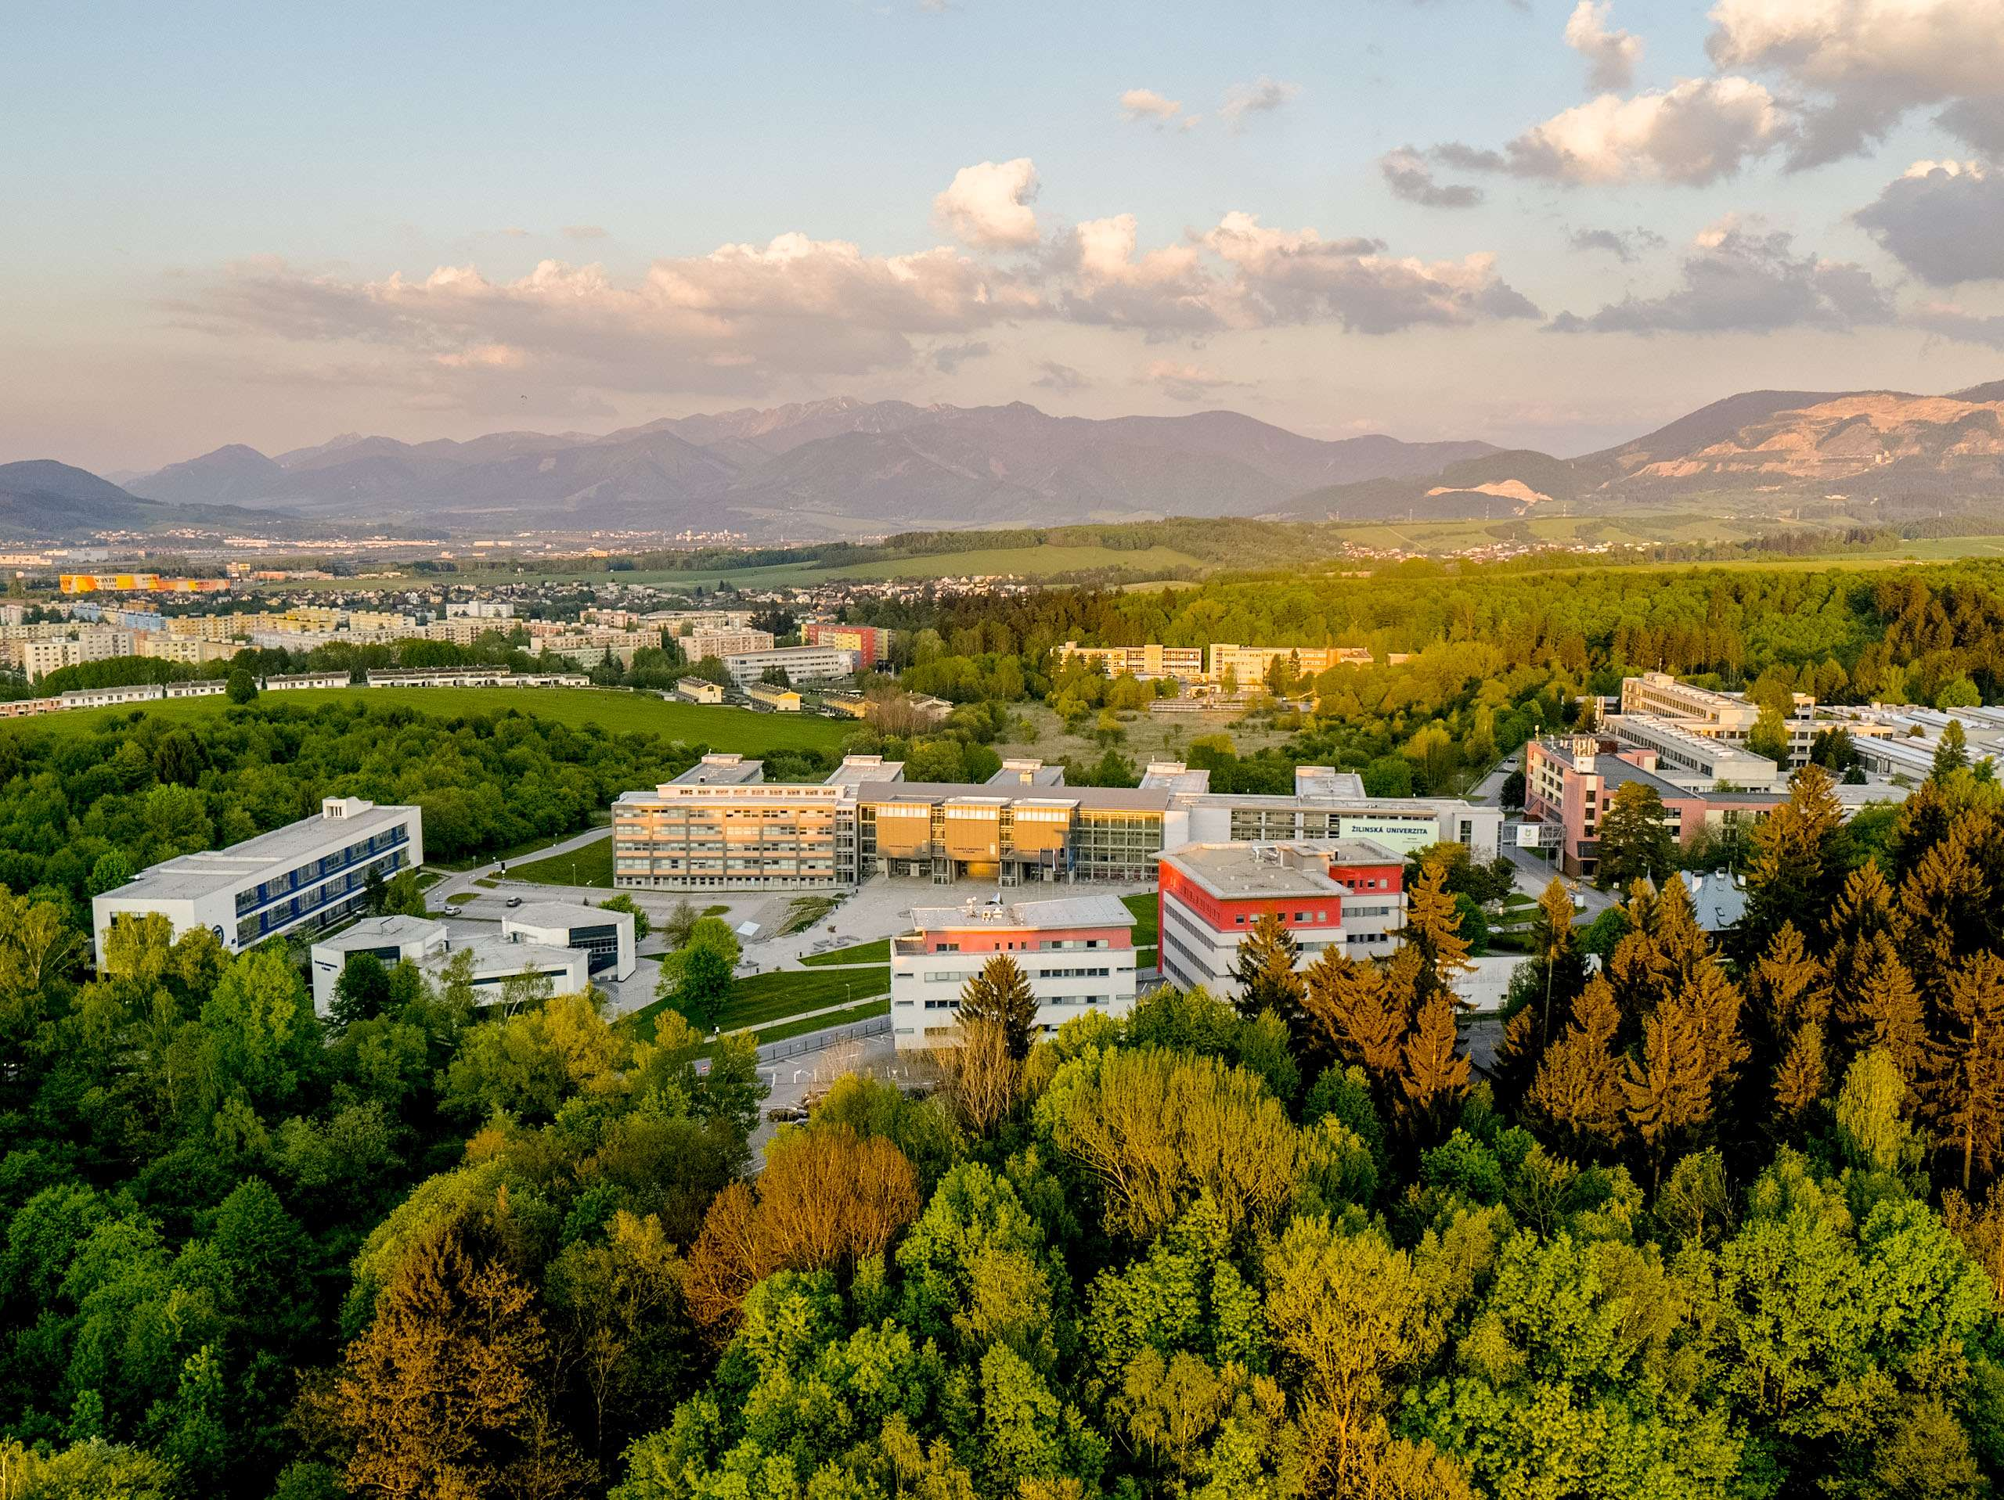


Conference Chairman

Tomas Kliestik
University of Zilina, Slovak Republic

Conference Guarantees

Tomas Kliestik
University of Zilina, Slovak Republic

Anna Krizanova
University of Zilina, Slovak Republic

Tatiana Corejova
University of Zilina, Slovak Republic

Scientific Committee
- assoc. prof. Adam P. BALCERZAK, University of Warmia and Mazury in Olsztyn, Poland
- prof. Ing. Jaroslav BELAS, PhD., Tomas Bata University in Zlin, Czech Republic
- assoc. prof. Yuriy BILAN, Ph.D., Rzeszów University of Technology, Poland
- prof. Jelena BOROCKI, University of Novi Sad, Serbia
- Dr. Martin CEPEL, PhD., MBA, Pan-European University, Slovak Republic
- assoc. prof. Ing. Viktor V. DENGOV, PhD., Saint Petersburg State University, Russian Federation
- prof. Preslav DIMITROV, PhD., South-West University Neofit Rilski, Bugaria
- Ing. Pavol DURANA, PhD., University of Zilina, Slovak Republic
- Mathilde FELSTEAD, PhD., Centre for Innovative Data-driven Smart Urban Ecosystems, Ohio, USA
- Anna FIELDEN, PhD., Centre for Industry 4.0-based Manufacturing Systems, Pennsylvania, USA
- prof. Ing. Beata GAVUROVA, MBA., PhD., Tomas Bata University in Zlin, Czech Republic
- prof. Ing. Valentina V. GERASIMENKO, PhD., Lomonosov Moscow State University, Russian Federation
- assoc. prof. Ing. Ales HES, CSc., University of Finance and Administration, Praha, Czech Republic
- Dr. Anita KOLNHOFER-DERECSKEI,Obuda University, Budapest, Hungary
- prof. Maria KICHEVA, PhD., South-West University Neofit Rilski, Bulgaria
- prof. Dr. Barbara KOS, PhD., Economics Academia, Katowice, Poland
- Ing. Maria KOVACOVA, PhD., University of Zilina, Slovak Republic
- assoc. prof. Ing. Pavol KRAL, PhD., University of Zilina, Slovak Republic
- prof. Justyna ŁAPIŃSKA, PhD., Nicolaus Copernicus University, Poland
- assoc. prof. George LAZAROIU, PhD., Spiru Haret University, Bucharest, Romania
- prof. Ing. Zbigniew LUKASIK, DrSc., University of Technology, Radom, Poland
- prof. Ing. Alexander N. LYAKIN, DrSc., Saint Petersburg State University, Russian Federation
- prof. Ing. Olga P. MOLCHANOVA, PhD., Lomonosov Moscow State University, Russian Federation
- prof. Ing. Hussam MUSA, PhD., Matej Bel University, Banska Bystrica, Slovak Republic
- assoc. prof. Zdenka MUSOVA, PhD., Matej Bel University, Banska Bystrica, Slovak Republic
- prof. univ. dr. Elvira NICA, Bucharest University of Economic Studies, Romania
- assoc. prof. Judit OLAH, PhD., University of Debrecen, Hungary
- Ing. Petra PARTLOVA, PhD., Institute of Technology and Business in Ceské Budejovice, Czech Republic
- prof. Michał PIETRZAK, PhD., Nicolaus Copernicus University, Poland
- prof. Ing. Jan POKRIVCAK, PhD., Slovak University of Agriculture in Nitra, Slovak Republic
- prof. Dr. Jozsef POPP, PhD., Szent Istvan University, Hungary
- prof. univ. dr. Gheorghe H. POPESCU, Dimitrie Cantemir Christian University, Bucharest, Romania
- Dr. Elżbieta ROGALSKA, PhD., University of Warmia and Mazury, Poand
- assoc. prof. Mariana SEDLIACIKOVA, PhD., Technical University in Zvolen, Slovak Republic
- assoc. prof. Pengfei SHENG, PhD., University of Henan, People Republic of China
- Mgr. Petr SULER, PhD., Institute of Technology and Business in Ceské Budejovice, Czech Republic
- assoc. prof. Vladimir URADNICEK, PhD., Matej Bel University, Banska Bystrica, Slovak Republic
- Ing. Katarina VALASKOVA, PhD., University of Zilina, Slovak Republic
- prof. Tetyana VASILYEVA, Sumy State University, Ukraine
- Dr. phil., prof. Velga VEVERE, EKA University of Applied Sciences, Latvia
- Ing. Zuzana VIRGLEROVA, PhD., Tomas Bata University in Zlin, Czech Republic
- prof. Ing. Marek VOCHOZKA, MBA, PhD., The Institute of Technology and Business in Ceske Budejovice, Czech Republic
- Ing. Jaromir VRBKA, MBA, PhD., Institute of Technology and Business in Ceské Budejovice, Czech Republic
- prof. Ing. Natalia A. ZHURAVLEVA, PhD., Emperor Alexander I St. Petersburg State Transport University, Russian Federation

Publishing Opportunities
- Oeconomia Copernicana (ISSN 2083-1277), an international journal indexed in: Web of Science – Current Contents, Social Sciences Citation Index, ESCI, EBSCO, EconLit, Index Copernicus International, and many otherbases
http://oeconomia.pl
- Analysis and Metaphysics (ISSN 1548-8574), an international journal indexed in: SCOPUS, ProQuest, EconLit, CEEOL, and many other bases
https://addletonacademicpublishers.com/analysis-and-metaphysics
- Contemporary Readings in Law and Social Justice (ISSN 1948-9137), an international journal indexed in: SCOPUS, ProQuest, EconLit, CEEOL, and many other bases
https://addletonacademicpublishers.com/contemporary-readings-in-law-and-social-justice
- Economics, Management, and Financial Markets (ISSN 1842-3191), an international journal indexed in: SCOPUS, ProQuest, EconLit, CEEOL, and many other bases
https://addletonacademicpublishers.com/economics-management-and-financial-markets
- Ekonomicko-manazerske spektrum (Economic and Managerial Spectrum) (ISSN 1337-0839), an international journal under evaluation in SCOPUS
https://ems.uniza.sk
- Equilibrium Quarterly Journal of Economics and Economic Policy (ISSN 1689-765X), an international journal indexed in: Web of Science – ESCI, EBSCO, EconLit, Index Copernicus International, and many other bases
http://economic-policy.pl
- Geopolitics, History, and International Relations (ISSN 1948-9145), an international journal indexed in: SCOPUS, ProQuest, EconLit, CEEOL, and many other bases
https://addletonacademicpublishers.com/geopolitics-history-and-international-relations
- Journal of Research in Gender Studies (ISSN 2164-0262), an international journal indexed in: SCOPUS, ProQuest, EconLit, CEEOL, and many other bases
https://addletonacademicpublishers.com/journal-of-research-in-gender-studies
- Journal of Self-Governance and Management Economics (ISSN 2329-4175), an international journal indexed in: SCOPUS, ProQuest, EconLit, CEEOL, and many other bases
https://addletonacademicpublishers.com/journal-of-self-governance-and-management-economics
- Journal of Risk and Financial Management; Special Issue: Financial and Systematic Risks of Enterprises (ISSN 1911-8074), an international journal indexed in: Web of Science, EconLit, DOAJ, ABDC and many others
https://www.mdpi.com/journal/jrfm/special_issues/FSRE
- International Journal of Financial Studies; Special Issue: Global Perspectives of Business Environment (ISSN 2227-7072); an international journal indexed in: Web of Science, Scopus, DOAJ, EconLit and many others
https://www.mdpi.com/journal/ijfs/special_issues/business_envir

Conference Program

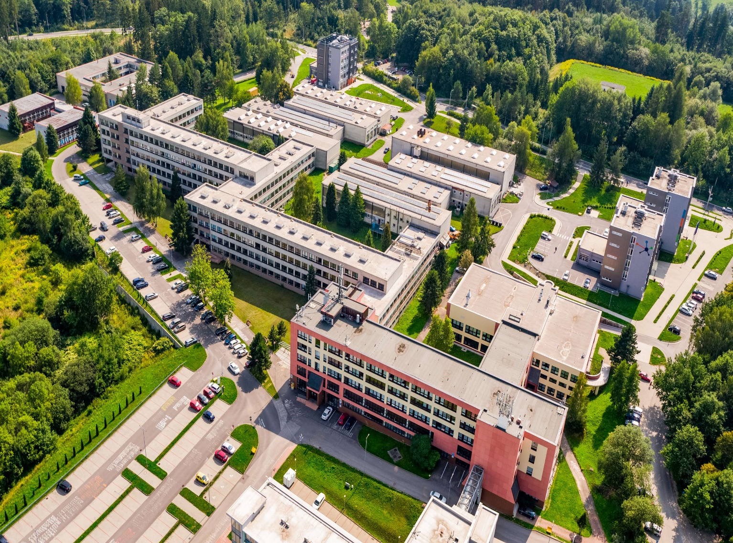

21 October 2020

9.00 – 9.20 Conference Opening

Tomas KLIESTIK – Editor and Guarantee of the conference; Head of the Department of Economics, Faculty of Operation and Economics of Transport and Communications, University of Zilina

9.20 – 11.30 Plenary Session

9.20 – 9.40 George LAZAROIU (Spiru Haret University, Romania)
Keynote speech: The adoption of mobile payment technologies, social interactiveconsumer-oriented applications, and online purchasers’ decision-making process

9.40 – 10.00 Marek VOCHOZKA (Institute of Technology and Business, Czech Republic)
Keynote speech: GDP development of China and USA in terms of mutual sanctions and COVID-19

10.00 – 10.20 Dan-Cristian DABIJA (Babeș-Bolyai University, Romania)
Keynote speech: Heavy work investment: an empirical approach in the context of COVID-19 pandemic

10.20 – 10.40 Preslav DIMITROV (South-West University Neofit Rilski, Bulgaria)
Keynote speech: The global incoming tourism flow in Turkey and its influence on the incoming tourism flow in the Mediterranean and Black sea countries

10.40 – 11.00 Velga VEVERE (EKA University of Applied Sciences, Latvia)
Keynote speech: Behavioural economics on higher education institution - Business collaboration paradigm in context of global competition

11.00 – 11.20 Adam P. BALCERZAK (University of Warmia and Mazury in Olsztyn, Poland)
Keynote speech: Effectiveness of institutions supporting entrepreneurship in the EU. Are “new” members the burden or the European advantage in the global competition?

11.30 – 12.30 Break

12.30 – 16.15 Session 1: Global impact of COVID 19 on Economy and Society
Session Chair: Katarina VALASKOVA

12.30 – 12.50 Irena NESTEROVA (University of Latvia, Latvia)
The global flood of COVID-19 contact tracing apps: sailing with human rights and data protection standards against the wind of mass surveillance

12.50 – 13.10 Joanna KUDEŁKO, Karol WAŁACHOWSKI, Dariusz ŻMIJA (Cracow University of Economics, Poland)
Post-covid-19 socio-economic transformation in Polish cities. Necessity of revolution 4.0.

13.10 – 13.30 Elena LYSENKO (Ural Federal University named after the first President of Russia B.N. Yeltsin, Russia)
Study of satisfaction with the organization of the studying process in remote mode during the COVID-19 pandemic: Case UrFU named after the first president of Russia B.N.Yeltsin

13.30 – 13.50 Julia TOKAREVA (Ural Federal University named after the first President of Russia B.N. Yeltsin, Russia)
Study of factors influencing the transformation of medical staff’s well-being in the context of the COVID -19 pandemic

13.50 – 14.10 Valerian DOLIDZE (Ivane Javakhishvili Tbilisi State University, Georgia)
Globalization and post-pandemic world order: Place of Georgia in transformative international system

14.10 – 14.30 Paweł NOWICKI (Cracow University of Economics, Poland)
Remote certification processes during global pandemic times

14.30 – 14.50 Ulviyya RZAYEVA (Azerbaijan State University of Economics, Azerbaijan)
University life during pandemic COVID-19: Attitudes of staff and students towards distance education

14.50 – 15.10 Viktor DENGOV, Irina TULYAKOVA (Saint Petersburg State University, Russia), Elena GREGOVA (University of Zilina, Slovakia)
Military spending and GDP: is there a mutual influence? (Study on the example of Russia)

15.10 – 15.30 Ilinka TERZIYSKA (South-West University Neofit Rilski, Bulgaria), Elka DOGRAMADJIEVA (Sofia University St. Kliment Ohridski, Bulgaria)
Should I stay or should I go? Global COVID-19 pandemic influence on travel intentions of Bulgarian residents

15.30 – 15.50 Madalina TABARCIA (Academy of Economic Studies in Bucharest, Romania)
Global impact of COVID-19 on 112 emergency system detailed for national 112 emergency system of Romania

15.50 – 16.10 Viktorija ŠIPILOVA (Institute of Humanities and Social Sciences of Daugavpils University, Latvia)
Structural change for sustainable development in economy: A literature review

22 October 2020

8.30 – 12.00 Session 2: Accounting, innovation and management in global economy
Session Chair: Katarina JANOSKOVA

8.30 – 8.50 Asta KAMANDULIENĖ (Vytautas Magnus University, Lithuania)
The impact of capital structure on financial performance of global listed companies

8.50 – 9.10 Maria MANGANIELLO (University of Naples “Parthenope”, Italy)
Sustainable equity crowdfunding projects: Are they a driving force to revitalise Italy after COVID -19?

9.10 – 9.30 Egidijus KUNDELIS (ISM University of Management and Economics, Lithuania)
Debt or profit shifting? Assessment of corporate tax avoidance practices across companies operating in small open economies: evidence from Lithuania

9.30 – 9.50 Soňa KLEŠTINCOVÁ (University of Economics in Bratislava, Slovak Republic)
Do taxes affect number of foreign enterprises controlled abroad by Slovak companies in the age of globalization?

9.50 – 10.10 Jana KUBICOVÁ (University of Economics in Bratislava, Slovak republic)
The network of bilateral tax treaties of the Slovak Republic – Does it mirror globalization through digitalization? A cluster analysis approach

10.10 – 10.30 Tomislava PAVIC KRAMARIC (University of Split, Croatia)
Determinants of accounting and market-based performance measures – Case of Croatian non-financial listed companies

10.30 – 10.50 Irina Gennad'evna ERSHOVA (South-Western state University, Kursk)
Regional human capital development management in the process of globalization

10.50 – 11.10 Inês GODINHO, Nuno MARQUES (Lusófona University, Porto)
Competition criminal law: An international and global trend?

11.10 – 11.30 Jaroslav KLÁTIK (Matej Bel University, Slovak Republic)
Electronic and informatization of the judiciary as a tool for innovation

11.30 – 11.50 Martin ORVISKÝ (Matej Bel University, Slovak Republic)
Telemedicine from the legal point of view

12.00 – 12.45 Break

12.45 – 16.30 Session 3: Sustainability in CSR and global economic resilience
Session Chair: Pavol DURANA

12.45 – 13.00 Monika SMELA (Prague University of Economics and Business, Czech Republic)
The qualitative comparative analysis: An overview of a causal complexity approach

13.00 – 13.20 Pavol SKOCDOPOLE (Slovak University of Agriculture in Nitra, Slovak Republic)
Financial analysis as a basis for creation of the financial plan of the selected business entity – Case study

13.20 – 13.40 Frantisek POLLAK (University of Economics in Bratislava, Slovak Republic)
Sustainable development of corporate reputation – Reputation analysis of the selected brands owned by the family businesses

13.40 – 14.00 Magdalena WOJNAROWSKA, SOŁTYSIK Mariusz, Maciej GUZIK (Cracow University of Economics, Poland)
Socio-economic importance of biomaterials in the transition to the circular economy model

14.00 – 14.20 Piotr KAFEL (Cracow University of Economics, Poland)
Packaging's of the organic farming products in the context of circular economy

14.20 – 14.40 Tomáš RIC (Czech University of Life Sciences Prague, Czech Republic)
Shopping tourism with a focus on the clothing industry in relation to globalization

14.40 – 15.00 Dagmar CAGÁŇOVÁ (Slovak University of Technology in Bratislava, Slovak Republic)
Consumer behavior in the meat market within the V4 countries: Social consequences for the length and quality of life

15.00– 15.20 Bartłomiej KABAJA (Cracow University of Economics, Poland)
Product packaging communication on the global market – Analysis of consumer behaviour

15.20 – 15.40 Zuzana DVORAKOVA (University of Chemistry and Technology Prague, Czech Republic)
Labor economics and career development in the context of globalized world

15.40 – 16.00 Greta GENELIENE (Mykolas Romeris University, Lithuania)
Evaluation of gambling sector activity in Lithuania, Latvia, Slovak Republic and Czech Republic

16.00 – 16.20 Lina Jakučioniene, Renata Matkevičiene, (Vilnius University, Lithuania)
How PR professionals react and adopt globalization challenges: Mapping of PR professional competencies based on information from webpages of international PR professional associations (2015-2020)

23 October 2020

8.30 – 12.00 Session 4: Economic consequences of globalization in Romania
Session Chairs: Katarina VALASKOVA, Pavol DURANA

8.30 – 8.45 Răzvan Cătălin DOBREA (Bucharest University of Economic Studies, Romania)
Globalization - a Cause or a Solution for Corona Economic Crisis

8.45 – 9.00 Iulian GOLE (Bucharest University of Economic Studies, Romania)
Aviation industry - challenges and uncertainties after the Covid-19 pandemic

9.00 – 9.15 Alexandru Dumitru BODISLAV (Bucharest University of Economic Studies, Romania)
Increasing the Efficiency of the Fiscal System – a Parallel between Poland and Romania

9.15 – 9.30 Daniel MOISE (Bucharest University of Economic Studies, Romania)
CoVid19, a Threat or a Blessing to Globalization?

9.30 – 9.45 Cristina DIMA (Bucharest University of Economic Studies, Romania)
The level of education of graduates in Romania in the context of globalization

9.45 – 10.00 Ovidiu Cristian Andrei BUZOIANU (Bucharest University of Economic Studies, Romania)
Analysis of the impact of globalization on the global labor force

10.00 – 10.15 Sorin BURLACU (Bucharest University of Economic Studies, Romania)
Sustainable Urban Development in the Context of Globalization and the Health Crisis Caused by the Covid-19 Pandemic

10.15 – 10.45 Victor Marian DUMITRACHE (Bucharest University of Economic Studies, Romania)
The dynamics of innovation in the ex-communist countries in Europe in the context of globalization

10.45 – 11.00 Alexandru Dumitru BODISLAV (Bucharest University of Economic Studies, Romania)
Are 2020's Social Movements Proof of the End of Globalization

11.00 – 11.15 Cristina DIMA (Bucharest University of Economic Studies, Romania)
Education and Employment in European Urban Communities

11.15 – 11.30 Ovidiu Cristian Andrei BUZOIANU (Bucharest University of Economic Studies, Romania)
Globalization and working conditions in developing countries

11.30 – 11.45 Sorin BURLACU (Bucharest University of Economic Studies, Romania)
E-government in the Era of Globalization and the Health Crisis caused by the Covid-19 Pandemic, between Standards and Innovation

11.45 – 12.00 Victor Marian DUMITRACHE (Bucharest University of Economic Studies, Romania)
The dynamics of human capital accumulation in the ex-communist countries in Europe in the context of globalization

Links to zoom webinars and youtube stream can be found at globalizacia.com

